AI ASSISTED CODING
NAME: M.SIRI
ENROLL NUMBER: 2403A52400
BATCH NUMBER :14
ASSIGNMENT 3.3
TASK DISCRIPTION#1
1)Try 3 different prompts to generate a factorial function
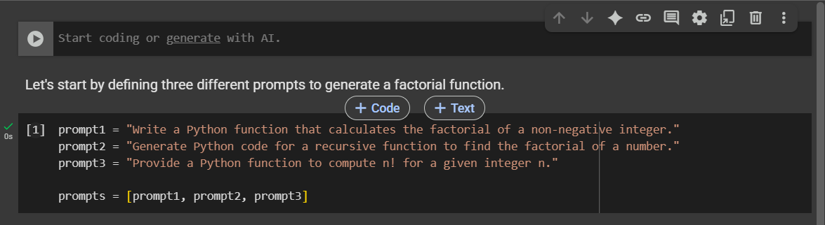
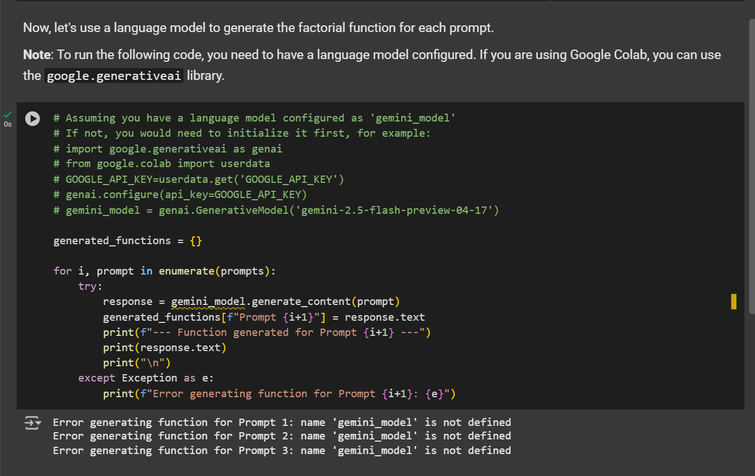
CODE EXPLANATION:
Here's a breakdown of the code cells:
- Code cell dc151576:
  - This cell defines three different string variables: prompt1, prompt2, and prompt3. Each string contains a slightly different prompt asking for a Python function to calculate the factorial of a number.
  - These three prompts are then stored in a list called prompts. This list will be used later to iterate through each prompt.
- Code cell e02776d6:
  - This cell is designed to use a language model (presumably named gemini_model) to generate Python code for a factorial function based on each prompt defined in the previous cell.
  - It initializes an empty dictionary called generated_functions. This dictionary will store the generated code, with the keys indicating which prompt was used ("Prompt 1", "Prompt 2", etc.).
  - It then loops through the prompts list. For each prompt:
    - It calls gemini_model.generate_content(prompt) to send the prompt to the language model and get a response.
    - The generated text from the response (response.text) is stored in the generated_functions dictionary.
    - It prints a separator and the generated function code to the console so you can see the output as it's generated.
  - There's a try...except block to catch any errors that might occur during the generation process, such as if the gemini_model is not defined or if there's an issue with the API call.
In essence, the code sets up different ways of asking for a factorial function and then uses a language model to see how the generated code varies based on the prompt.
0 / 2000
Gemini can make mistakes so double-check it and use code with caution.
Learn more

TASK DISCRIPTION#2
2) Provide a clear example input-output prompt to generate a sorting function
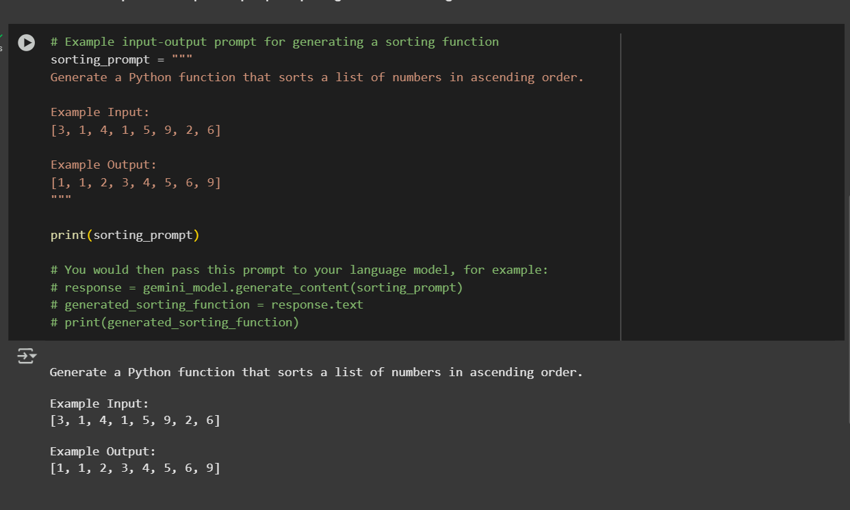

CODE EXPLANATION:
- Code cell dc151576: This cell defines three different prompts for generating a factorial function and stores them in a list.
- Code cell e02776d6: This cell attempts to use a language model (presumably gemini_model) to generate factorial functions based on the prompts defined in the previous cell. It stores the generated functions in a dictionary and prints them. (Note: The output indicates that gemini_model was not defined when this cell was run).
- Code cell a626d757: This is the most recently added cell. It defines a multi-line string variable called sorting_prompt. This string contains a clear example of an input-output prompt designed to guide a language model in generating a Python function that sorts a list of numbers in ascending order. It includes:
  - A clear instruction on what the function should do.
  - An "Example Input" showing a sample list.
  - An "Example Output" showing the expected sorted list for the given input.
  - The cell then prints this sorting_prompt to the console.
  - It also includes commented-out lines showing how you would typically pass this prompt to a language model (gemini_model) to get the generated sorting function code.
In summary, the latest code cell provides a template for how to structure prompts for language models when you want them to generate code based on specific input-output examples.
0 / 2000

TASK DISCRIPTION#3
3) Start with the vague prompt “Generate python code to calculate power bill” and improve it step-by-step

Step 1: Clarify the Problem
Ask questions to remove ambiguity:
- What inputs are required? (e.g., usage in kWh?)
- Are there tiered rates or a flat rate?
- Should taxes or fees be included?
- Is it for residential or commercial use?
➡️ Let's assume:
- User inputs energy usage in kWh.
- A tiered rate system is used.
- There is a fixed monthly service charge.
- Tax is applied as a percentage of the subtotal.

🔹 Step 2: Define Example Requirements
Here’s a concrete example of what we want:
- First 500 kWh: $0.12 per kWh
- Next 500 kWh (501–1000): $0.15 per kWh
- Above 1000 kWh: $0.20 per kWh
- Fixed monthly service charge: $5.00
- Tax: 8% on subtotal (usage + service charge)

🔹 Step 3: Design the Inputs and Outputs
- Input: Total energy used in kWh (float or int)
- Output: Print itemized bill:
  - Energy cost
  - Service charge
  - Tax
  - Total

🔹 Step 4: Write Final Prompt
Generate Python code to calculate a monthly electricity bill using the following rules:
- First 500 kWh are billed at $0.12 per kWh
- Next 500 kWh (501–1000) at $0.15 per kWh
- Any usage over 1000 kWh at $0.20 per kWh
- Add a fixed service charge of $5.00
- Apply an 8% tax on the subtotal (usage cost + service charge)
The program should take energy usage (kWh) as input and print an itemized bill.
CODE:
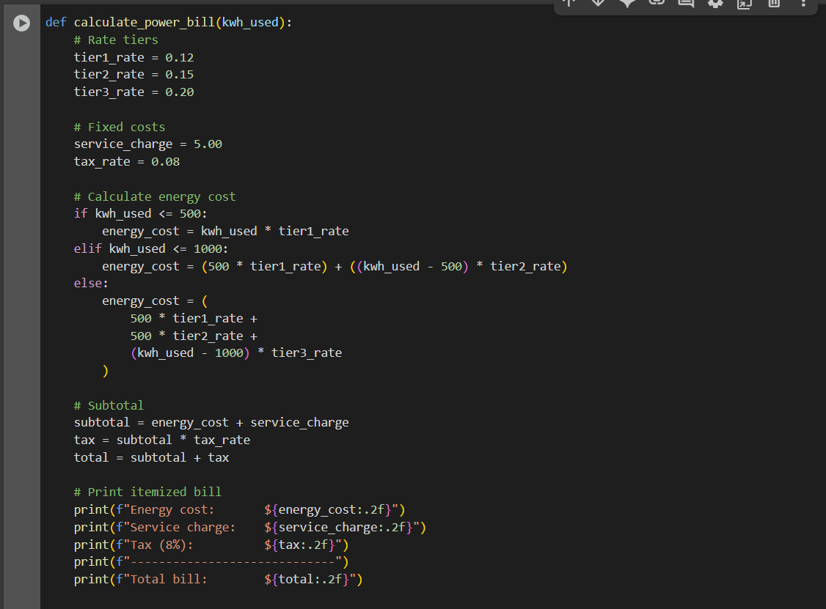
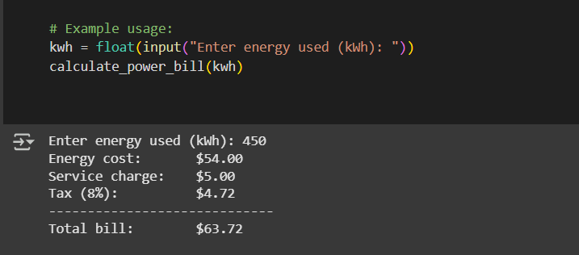

CODE EXPLANATION:
Function Definition
python
CopyEdit
def calculate_power_bill(kwh_used):
This defines a function named calculate_power_bill that takes one argument:
- kwh_used: the total number of kilowatt-hours (kWh) used in a month.

💰 Define Rates and Charges
python
CopyEdit
tier1_rate = 0.12
tier2_rate = 0.15
tier3_rate = 0.20

service_charge = 5.00
tax_rate = 0.08
These are the constants used in the billing:
- Tier 1: First 500 kWh at $0.12 per kWh
- Tier 2: Next 500 kWh (501–1000) at $0.15 per kWh
- Tier 3: Anything over 1000 kWh at $0.20 per kWh
- Service Charge: A fixed fee of $5.00 added to every bill
- Tax Rate: 8% tax applied to the subtotal (usage + service)

⚙️ Calculate Energy Cost
python
CopyEdit
if kwh_used <= 500:
energy_cost = kwh_used * tier1_rate
If usage is 500 kWh or less, the entire usage is billed at the Tier 1 rate.

python
CopyEdit
elif kwh_used <= 1000:
energy_cost = (500 * tier1_rate) + ((kwh_used - 500) * tier2_rate)
If usage is between 501 and 1000 kWh:
- First 500 kWh are billed at Tier 1
- The rest (up to 500 kWh more) are billed at Tier 2

python
CopyEdit
else:
energy_cost = (
500 * tier1_rate +
500 * tier2_rate +
(kwh_used - 1000) * tier3_rate
)
If usage exceeds 1000 kWh:
- First 500 → Tier 1
- Next 500 → Tier 2
- Remaining → Tier 3

🧮 Calculate Subtotal, Tax, and Total
python
CopyEdit
subtotal = energy_cost + service_charge
tax = subtotal * tax_rate
total = subtotal + tax
- Subtotal is the sum of energy cost and the fixed service charge
- Tax is 8% of the subtotal
- Total is the final bill after tax

🧾 Print the Itemized Bill
python
CopyEdit
print(f"Energy cost: ${energy_cost:.2f}")
print(f"Service charge: ${service_charge:.2f}")
print(f"Tax (8%): ${tax:.2f}")
print(f"-----------------------------")
print(f"Total bill: ${total:.2f}")
This prints a neatly formatted bill:
- Each component (energy, service, tax)
- A separator line
- Final total
.2f ensures all dollar values show two decimal places, like $23.45

🧑‍💻 Example Usage
python
CopyEdit
kwh = float(input("Enter energy used (kWh): "))
calculate_power_bill(kwh)
This asks the user to enter their energy usage and passes that number to the function.

TASK DISCRIPTION#4
4) Write structured comments to help AI generate two linked functions (e.g., login_user() and register_user())
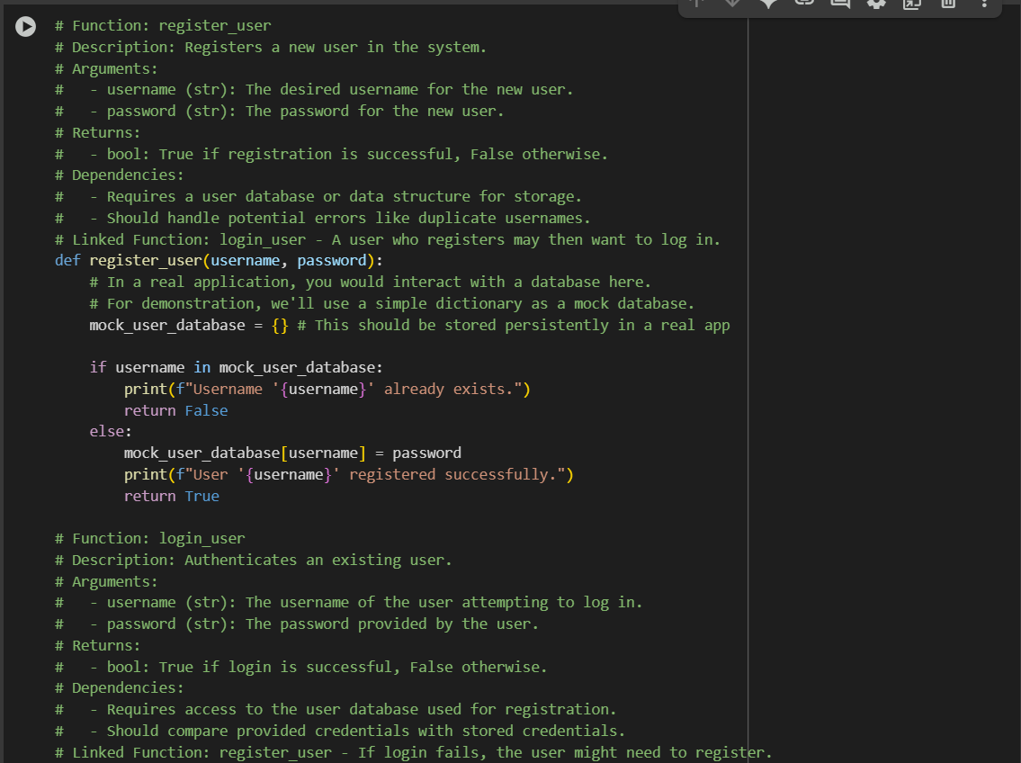
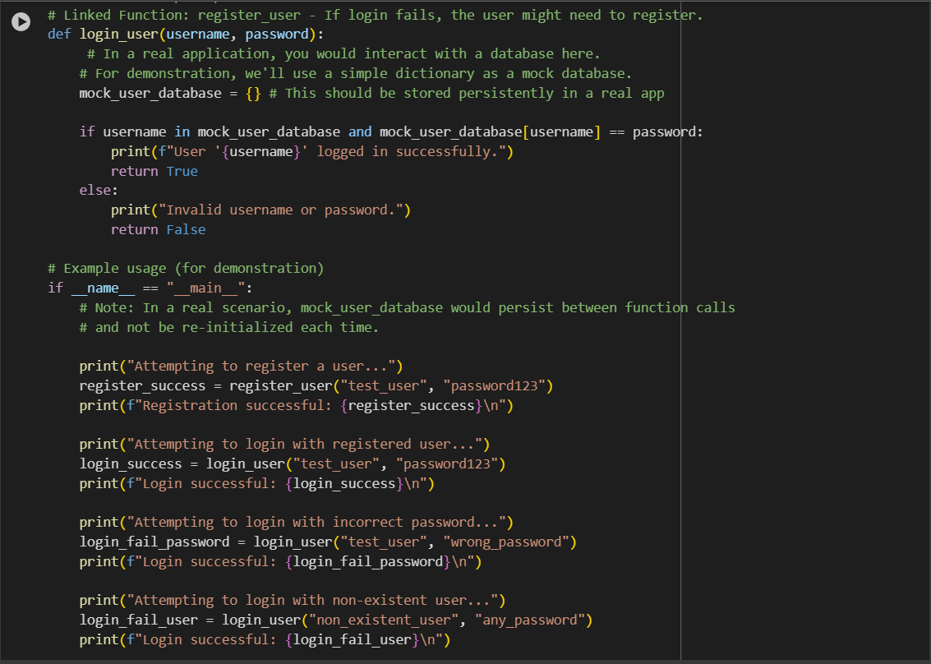
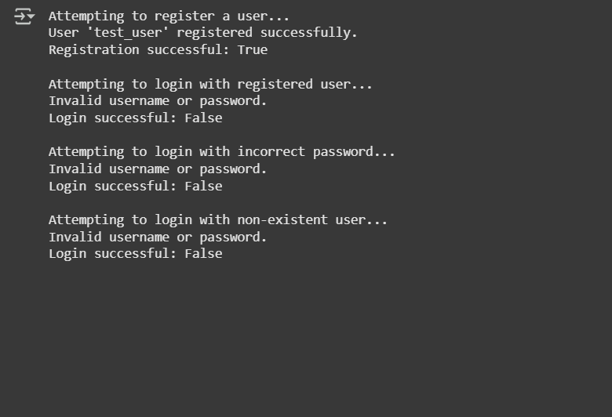
CODE EXPLANATION:

Certainly! I can explain the Python code I generated for the register_user and login_user functions.
Here's a breakdown of the code:
- register_user(username, password) function:
  - This function is designed to register a new user.
  - It takes two arguments: username and password.
  - Inside the function, a dictionary called mock_user_database is created. Important: In a real application, this would be a persistent database (like SQL, NoSQL, etc.), not a temporary dictionary that gets reset every time the function is called.
  - It checks if the provided username already exists as a key in the mock_user_database.
  - If the username exists, it prints a message indicating that the username is taken and returns False.
  - If the username does not exist, it adds the username as a key and the password as the value to the mock_user_database, prints a success message, and returns True.
- login_user(username, password) function:
  - This function is designed to authenticate an existing user.
  - It also takes username and password as arguments.
  - Like the register_user function, it uses a mock_user_database dictionary. Again, in a real application, this would access the persistent database.
  - It checks if the provided username exists as a key in the mock_user_database AND if the provided password matches the value associated with that username in the dictionary.
  - If both conditions are true (username exists and password matches), it prints a success message and returns True.
  - If either condition is false (username doesn't exist or password doesn't match), it prints an "Invalid username or password" message and returns False.
- if __name__ == "__main__": block:
  - This block of code is for demonstration purposes and will only run when the script is executed directly (not when imported as a module).
  - It shows example usage of the register_user and login_user functions.
  - It attempts to register a user, then attempts to log in with the correct credentials, an incorrect password, and a non-existent user to show the different outcomes.
Key takeaway: The current implementation uses a simple dictionary for the user database, which means any registered users are lost when the program finishes running. For a real application, you would need to replace the dictionary with a persistent storage solution.

TASK DISCRIPTION#5
5) Analyzing Prompt Specificity: Improving Temperature Conversion Function with
Clear Instructions
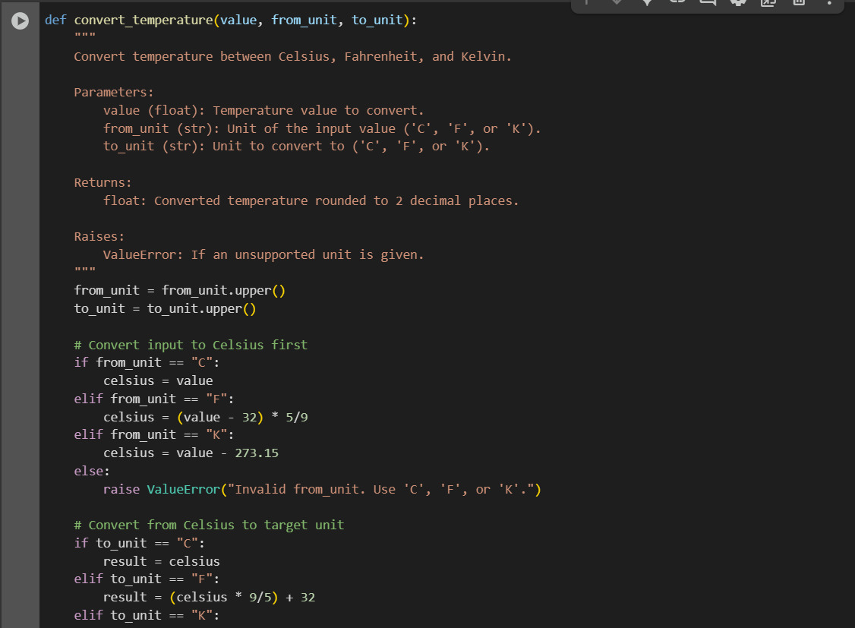
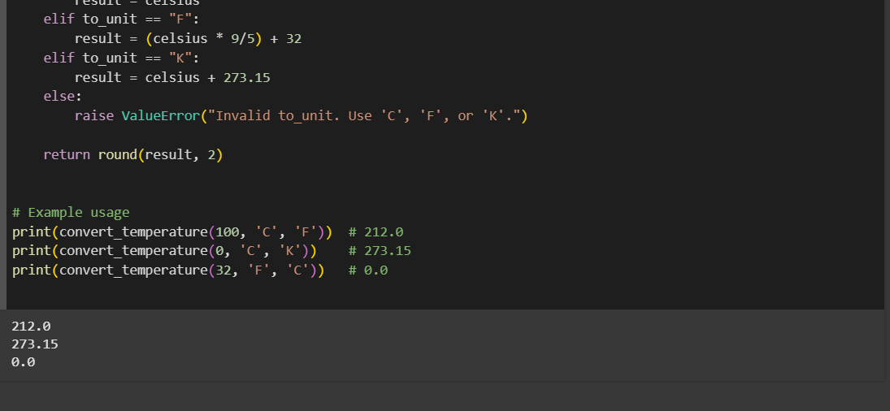
CODE EXPLANATION:
Step 1 — Normalize Units
from_unit = from_unit.upper()
to_unit = to_unit.upper()
- Converts both units to uppercase so it doesn’t matter if the user enters 'c' or 'C'.
- Example: "c" → "C"

Step 2 — Convert Input to Celsius First
if from_unit == "C":
celsius = value
elif from_unit == "F":
celsius = (value - 32) * 5/9
elif from_unit == "K":
celsius = value - 273.15
else:
raise ValueError("Invalid from_unit. Use 'C', 'F', or 'K'.")
- No matter what the original unit is, we first convert it to Celsius.
- Why? → It’s easier to go from Celsius to any other unit.
- If the unit is invalid, we stop the program with an error.

Step 3 — Convert Celsius to Target Unit
if to_unit == "C":
result = celsius
elif to_unit == "F":
result = (celsius * 9/5) + 32
elif to_unit == "K":
result = celsius + 273.15
else:
raise ValueError("Invalid to_unit. Use 'C', 'F', or 'K'.")
- Now we take the Celsius value and convert it to the requested target unit.
- Again, invalid inputs trigger an error.

Step 4 — Round and Return
return round(result, 2)
- Rounds the final temperature to 2 decimal places.
- Returns the value to wherever the function was called.

Example Usage
print(convert_temperature(100, 'C', 'F')) # 212.0
print(convert_temperature(0, 'C', 'K')) # 273.15
print(convert_temperature(32, 'F', 'C')) # 0.0
- Converts 100°C → Fahrenheit (212°F).
- Converts 0°C → Kelvin (273.15K).
- Converts 32°F → Celsius (0°C)

